**Lab 6: Times Ten Attenuator**

Daniel Komac

EEE 117L

2:00pm-4:50pm

**Purpose:** To understand and analyze the “Times ten” attenuation that is obtained from the 10X oscilloscope probe. We built a circuit to replicate this exact scenario.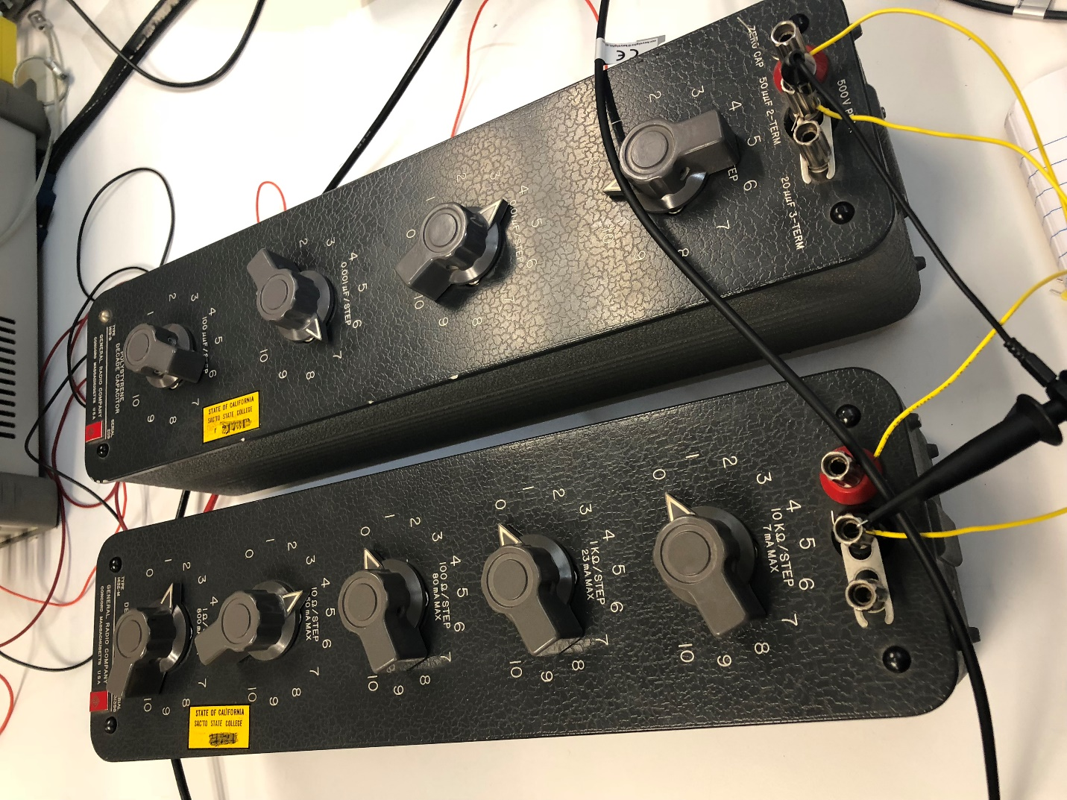

**Data:** 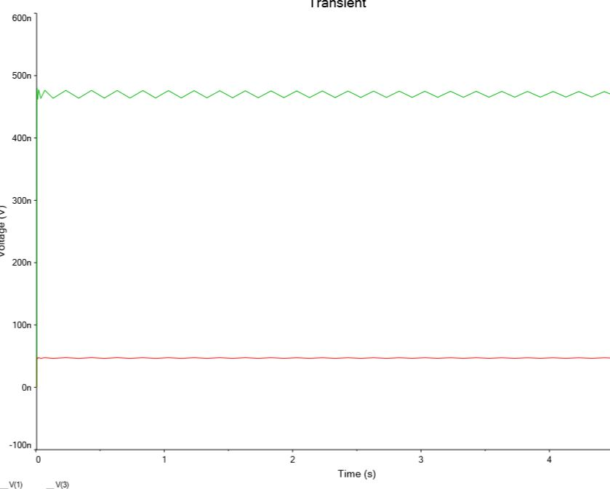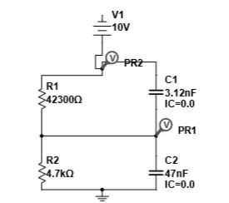 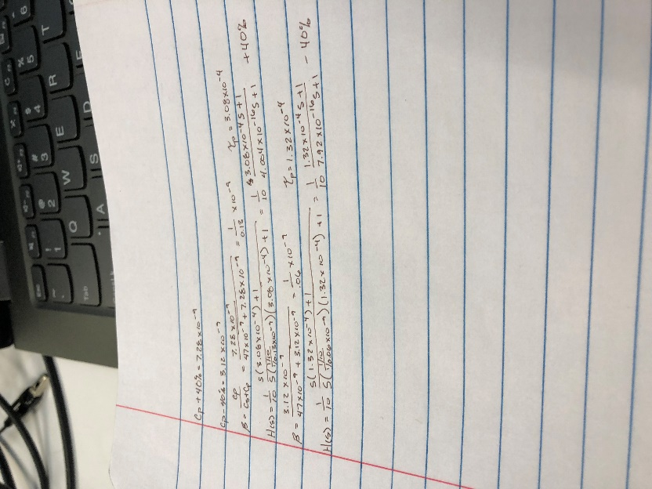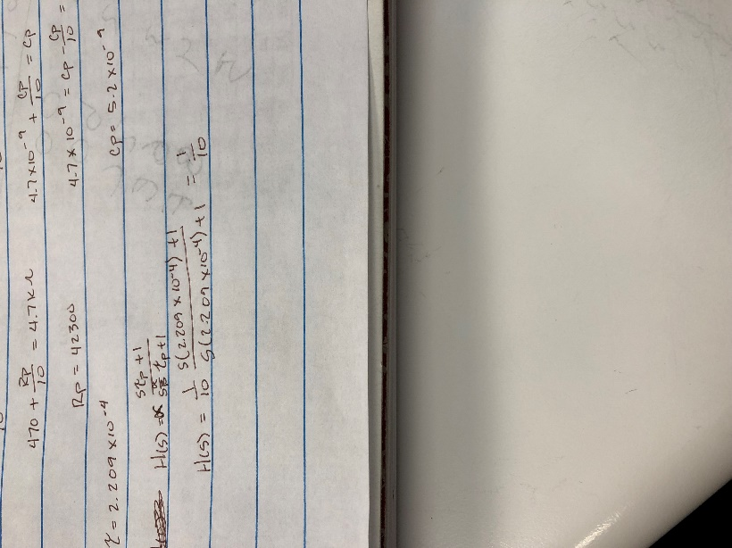

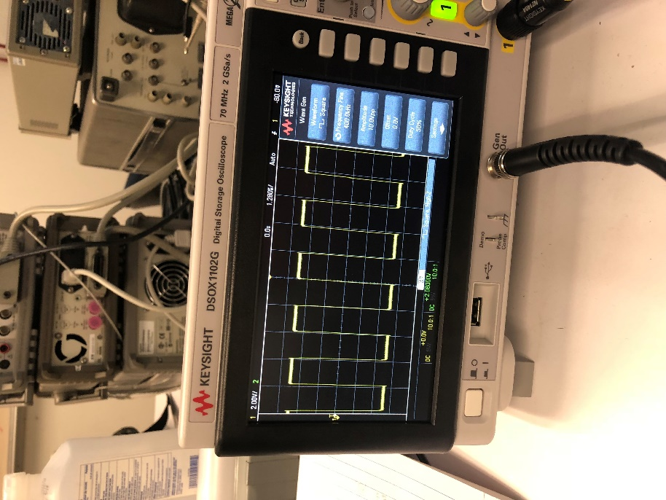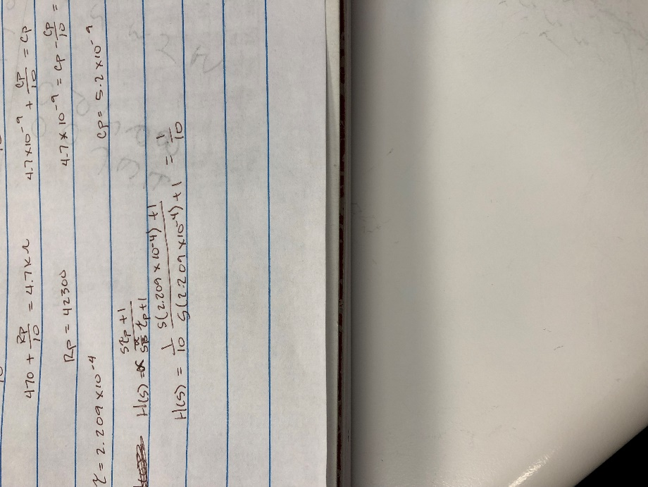

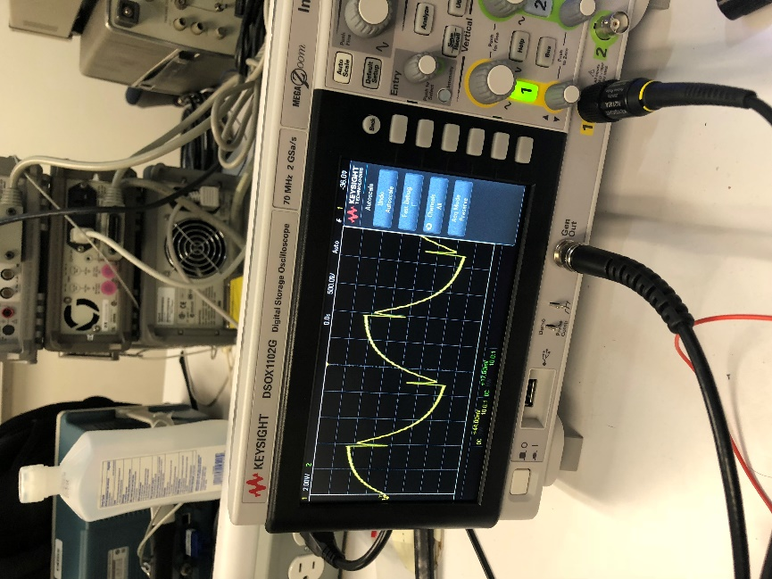

**Conclusion:** After using the Oscilloscopes to find incorrect display of what was supposed to be attained. We fiddled around to eventually attained a square wave, the square wave had a tiny bit of over compensation and under compensation that was around what we theorized. To be honest this lab was a little confusing and rough to follow, generally confusing. We never got to the second part and never got to the bode diagram.